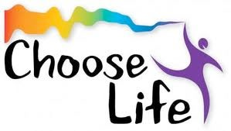

Issue No. 43
Newsletter
1st December 2023

On behalf of the Vocations Ireland Executive I want to take this time to wish you all a very blessed and holy Christmas. Christmas for many of us still evokes a sense of mystery and magic and we can’t help but focus on family, community, and God’s gift of becoming human to share in our lives in a most intimate way. The holy family continues to mirror family life around the world where families are struggling to find shelter and a warm place to rest, where they have been displaced and find themselves in a foreign land and where they are dependent on the kindness of strangers to survive. Yet love always survives and the love of God mirrored in our family and religious lives remains a strong witness to this. May this Christmas be a time of grace for all of you, for your communities, families and various ministries. We have a lot to be grateful for and Christmas can be a time of reflection before we focus on what is to come in the New Year.
All the Executive wish to thank you for your support, prayers, suggestions and passion during the past year and we know you will have the same energy and enthusiasm in 2024.

God bless and Happy Christmas to you all.

Fr Colm O Mahony OSA and members of the
Vocations Ireland Executive
Vocations Ireland, AMRI Office, C/O Missionaries of Africa, Cypress Grove Road, Templeogue,
Dublin 6W YV12 Phone: 086 782 0149
Email: vocations@amri.ie Web: www.vocationsireland.com Charity Registration Number: CHY 16272

Thank you to all who attended our Annual conference in Gort Mhuire on Saturday 25th November A special thanks to the Carmelite Community in Gort Mhuire for the use of their facilities.
Thanks to Fr Cyril Odia SDB for his wonderful presentation and to Margaret Cartwright and Anne Marie Whelan for their workshops. Thanks to all who helped with registration and in any way to help prepare for and assist on the day.

if you or anyone you know did not receive the conference invitation please ask them to send their name and email address to Margaret by EMAIL to vocations@amri.ie so we can update our database of contacts.

EXECUTIVE CHANGES

Thank you to our outgoing members of the Executive for their tremendous contributions over the last 6 years. Sr Fionnuala Qunn OP, Br Rupert O’Sullivan FPM, Fr Malachy Thompson OCSO and Sr Mary Healey from the Carmelites of the Aged and Infirm.

The following people were nominated and accepted to form the new executive.
Sr Jeanne Bott OSB, Sr Eileen O’Connell OP, Br Kevin Mascareuhas,FPM and Fr Cyril Odiia,SDB They will join with Fr Colm O’Mahony OSA, Sr Carmel Ryna DC, Sr Mary Usifoh OLA, Ms Michelle Robertson lay representative to form the new Executive.

Congratulations to each one and blessings on your ministry.

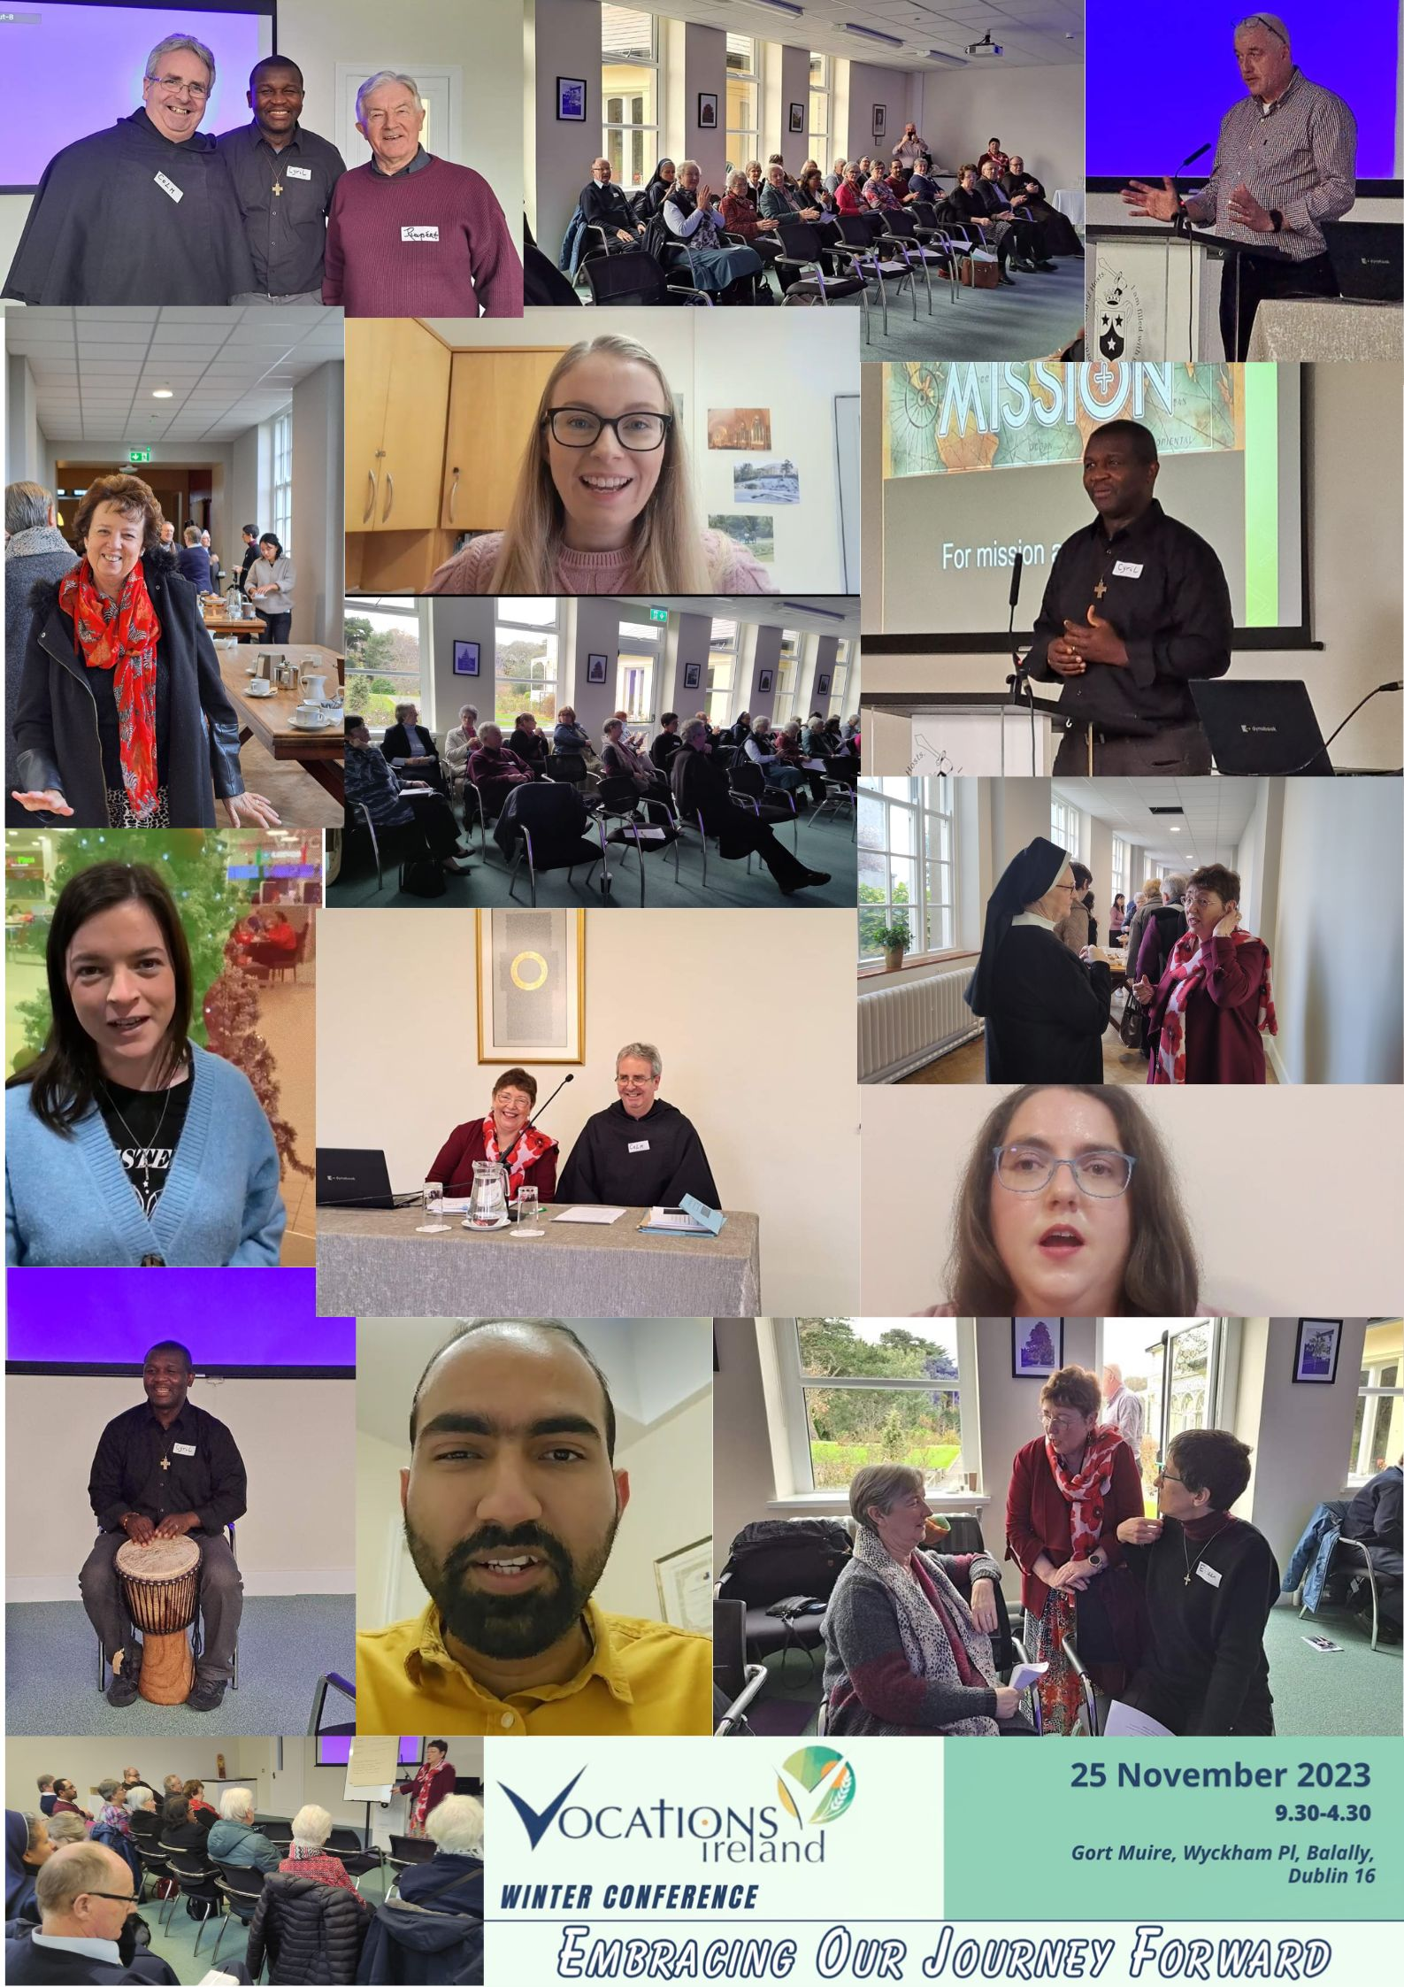

CHRISTMAS HOLIDAY OFFICE CLOSURE

The Vocations Ireland office will be closed from 30th November 2023 until 16th January 2024. All emails or phone messages will be responded to on my return.
Members of Vocations Ireland gathered in Gort Mhuire on Saturday 25th November for the Winter Conference and were joined by members and staff of AMRI. The theme of the day ‘Embracing Our Journey Forward’ helped all present to look to the future with hope. We joined the Carmelite Community to start the day celebrating Mass together. Fr Colm O Mahony welcomed all and Margaret Cartwright gave a presentation on the work of Vocations Ireland and in particular the merge with AMRI.
Fr Cyril Odia SDB gave a very energising talk on Formation in Mission. His main focus was accompanying young people where they are. His current mission allows him to accompany young people in schools, in St Catherines and St Patricks Maynooth, in Nigeria and with Salesian youth all over the world.
The conference was held on the eve of the Feast of Christ the King, the day that Pope Francis asks that we celebrate World Youth Day at local level. We celebrated the wonderful time had by all who attended World Youth Day in Lisbon earlier this year. Some young people who attended shared with us how the pilgrimage strengthened and affirmed their faith, and how travelling with different groups, including the AMRI and Vocations Ireland group, Diocese of Cork and Ross group, Bon Secours Young Adult group and the Salesian Young Adults, being with religious and people of their own age has changed their perspective on faith in Ireland and assured them that they are not alone. Thank you to Maria Munnelly, Br Simon Fernandez, Sheila Kelleher, Charlene Duff and Zaur Samadov who allowed us to celebrate this great moment in their lives by journeying to Lisbon with them and shared with us so warmly of their experience.
The two workshops were facilitated by Margaret Cartwright, Vocations Ireland and Anne-Marie Whelan, Evangelisation & Vocations Officer with Sisters of Bon Secours. Margaret focused on accompanying Young Adults, and Anne-Marie spoke with the group on how to be more visible at events, and how to collaborate with each other.
Some members of the current executive who have come to the end of their terms were thanked for their commitment to Vocations Ireland and new members were welcomed to the executive.
Days like this are so important for all in vocation ministry to network, to hear from each other, and to learn more about the current reality. Having a space like Gort Mhuire for the day made us all feel very much at home, and gave us all a chance to be energised on our journey as we move forward.

Anne-Marie Whelan
Evangelisation & Vocations Officer
Sisters of Bon Secours Ireland

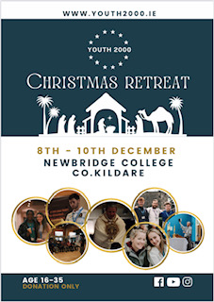

If you are interested in sharing a stand at the upcoming Youth 2000 Christmas Retreat, please contact Anne-Marie by Monday 4th December on awhelan@congregation.bonsecours.ie
You can also make a donation to Youth 2000 towards the retreat at www.youth2000.ie

USEFUL RESOURCES. & NICE CHRISTMAS PRESENTS
FAITH In Search of Greater Glory in Sport.
By Gerard Gallagher. Publisher Hero Books. Available at Veritas https://www.veritasbooksonline.com/faith-in-search-of-greater-glory-in-sport-9781910827567-49049/
Advent News Too Good to Keep. By Gerard Gallagher Available at Veritas
https://www.veritasbooksonline.com/advent-news-too-good-to-keep-9781847309792-46126/
https://www.fruugo.ie/advent-news-too-good-to-keep-by-gerard-gallagher/p-55568818-112711497
God’s Call is Everywhere. A global analysis of Contemporary Religious vocations for Women
https://www.amazon.co.uk/Gods-Call-Everywhere-Contemporary-Religious/dp/0814669131
https://blackwells.co.uk/bookshop/product/Gods-Call-Is-Everywhere-by-Patricia-Wittberg/9780814669136
Memoirs “Looking Back “ Sr Berardin, Rose McCormack OLA From the OLA Province
Sensing the Spirit Toward the future of Religious Life Judith A. Merkle publisher T&T Clarke Bloomsbury Publishing Plc.
https://www.bloomsbury.com/uk/sensing-the-spirit-9780567706997/
https://www.dubraybooks.ie/product/sensing-the-spirit-9780567706997
Calm the Soul. Poor Clares Galway. Updated 10th anniversary edition Hatchette books Ireland
https://www.easons.com/calm-the-soul-poor-clares-9781399729192
https://www.veritasbooksonline.com/calm-the-soul-a-book-of-simple-wisdom-and-prayer-9781399729192-50840/
https://www.dubraybooks.ie/product/calm-the-soul-hb-9781399729192

